**Experiment No. 7**

|  |  |  |  |
| --- | --- | --- | --- |
| **Student Name:** | Nikhil | **UID:** | 21BNM2021 |
| **Branch:** | BSC CSM | **Section/Group:** | A |
| **Semester:** | 5 | **Date of Performance:** | 30-10-23 |
| **Subject Name:** | Web Design Lab | **Subject Code:** | 21SCP-322 |

|  |  |
| --- | --- |
| **Statement** | Implement Validation in the Feedback Form.   1. Use regular expression for validation in Feedback Form 2. Using ajax retrieve data from a TXT file and display it. |
| **Aim** | Using ajax to retrieve data |
| **Objectives** | 1. Use regular expression for validation in Feedback Form 2. Using ajax retrieve data from a TXT file and display it. |
| **Language** | HTML, CSS, JavaScript |

**Code:**

<!DOCTYPE html>

<html>

<head>

<title>Feedback Form</title>

</head>

<body style="background-color: bisque;">

<h1>Feedback Form</h1>

<form id="feedbackForm">

<label for="name">Name:</label>

<input type="text" id="name" name="name" required><br><br>

<label for="email">Email:</label>

<input type="email" id="email" name="email" required><br><br>

<label for="mobile">Mobile No:</label>

<input type="tel" id="mobile" name="mobile" required pattern="[0-9]{10}"><br><br> <label>Gender:</label>

<input type="radio" id="male" name="gender" value="Male"> Male

<input type="radio" id="female" name="gender" value="Female"> Female <br><br>

<label for="color">Favorite Color:</label>

<select id="color" name="color" required>

<option value="Red">Red</option>

<option value="Green">Green</option>

<option value="Blue">Blue</option>

<option value="Yellow">Yellow</option>

</select>

<br><br>

<button type="button" id="submitBtn">Submit</button>

</form>

<br><br>

<h2>Feedback Summary</h2>

<textarea id="feedbackSummary" rows="5" cols="40" readonly></textarea>

<script src="https://code.jquery.com/jquery-3.6.0.min.js"></script>

<script>

$(document).ready(function() {

$("#submitBtn").click(function() { if

($("#feedbackForm")[0].checkValidity()) { // Combine and display the information var name = $("#name").val(); var email =

$("#email").val(); var mobile =

$("#mobile").val(); var gender = $("input[name='gender']:checked").val(); var color = $("#color").val(); var feedbackInfo = "Name: " + name + "\n" +

"Email: " + email + "\n" +

"Mobile No: " + mobile + "\n" +

"Gender: " + gender + "\n" +

"Favorite Color: " + color;

$("#feedbackSummary").val(feedbackInfo);

// Use AJAX to retrieve data from a TXT file and display it

$.ajax({

url: 'D:\UNI\CU (BSc CSM)\Sem05\Web Designing Lab\data.txt',

success: function(data) { $("#feedbackSummary").val(feedbackInfo + "\n\nData from TXT file:\n" + data);

}, error: function() {

$("#feedbackSummary").val(feedbackInfo + "\n\nFailed to retrieve data from TXT file.");

}

});

} else { alert("Please fill in all the required fields with valid data.");

}

});

});

</script>

</body>

</html>

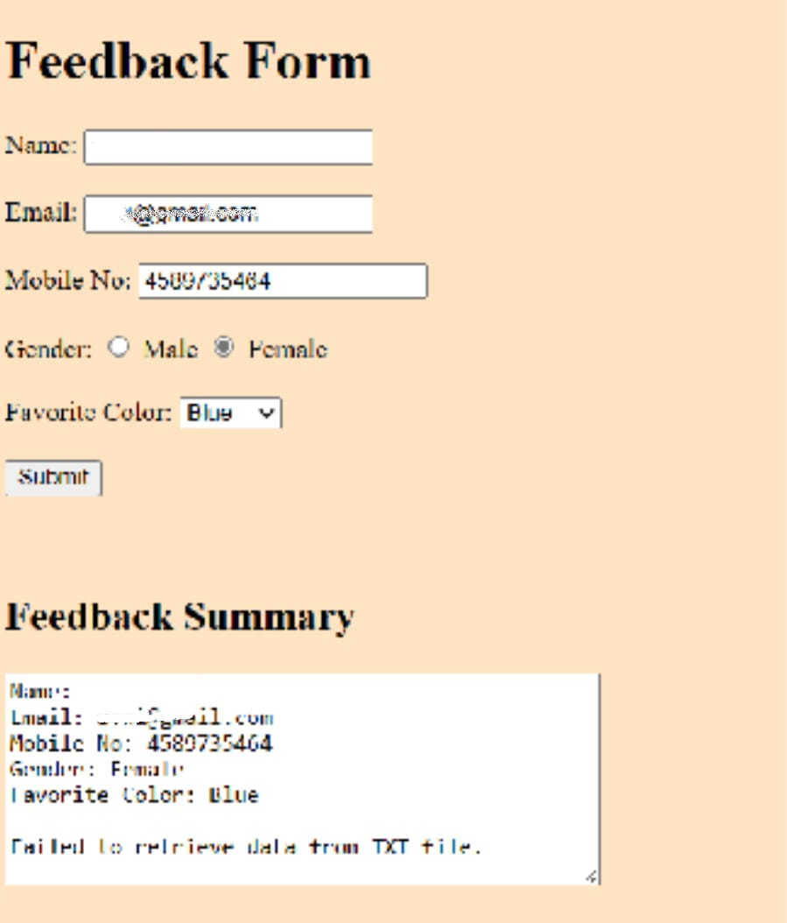

**Observations/Outcomes:**

**Evaluation Grid (To be created as per the SOP and Assessment guidelines by the faculty):**

|  |  |  |  |
| --- | --- | --- | --- |
| **S.N.** | **Parameters** | **Marks Obtained** | **Maximum Marks** |
| **1.** | Conduct of Experiment |  | 12 |
| **2.** | Viva-voce |  | 10 |
| **3.** | Submission of Work Sheet |  | 08 |